22nd ANNUAL

Rural West Internship Program

for Diversity in

Nonprofit Housing and Community Development

California, Oregon and Washington State

2019-2020

intern pROGRAM APPLICATION

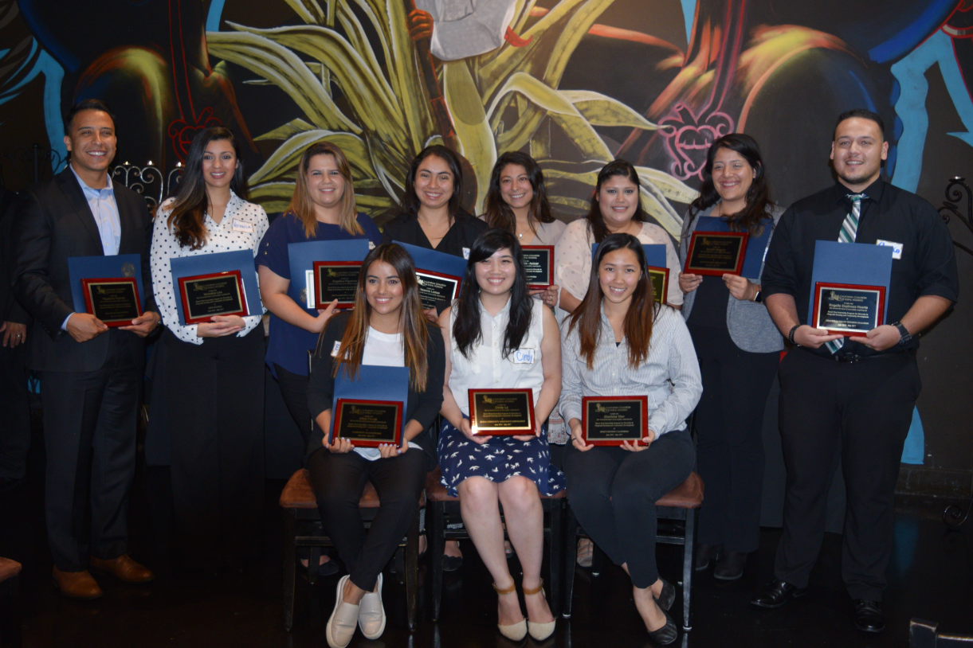

Deadline to Apply: May 10, 2019,
but applications will be accepted until positions are filled

Bilingual/Bicultural applicants strongly encouraged to apply.

A program of the California Coalition for Rural Housing

For additional information, please check the website

at: https://www.calruralhousing.org/next-generation-leadership-developm

program description and application form

(Please read carefully before applying)

The California Coalition for Rural Housing (CCRH) is proud to announce its 22nd Annual Rural West Internship Program for Diversity in Nonprofit Housing and Community Development (Internship Program). The Program has operated in California for the last 21 years and is excited to offer opportunities for an eight year in Washington State and Oregon.

About the Program’s Objectives
The CCRH Internship Program is a one-year paid Internship designed to recruit, train, and retain housing development professionals who enhance inclusion and racial equity within the Affordable Housing Development field. CCRH member nonprofit organizations have responded to the need for affordable housing by building, maintaining and rehabilitating affordable housing complexes in the rural West since the 1960s. This internship is intended to provide an entry into the affordable housing and community development field to historically underrepresented college students from low-income, rural, farmworker and ethnically diverse communities representative of the growing diverse populations served by these nonprofit housing developers. We strongly encourage applications from students entering their last year of college, recent graduates or graduate students in their last year so that upon graduating from college, they may be able to be employed in entry-level professional positions in the field (see list of locations listed on page 5). All majors are welcome to apply.

How the Internship Works
There are three main entities that make up the program: the Intern, CCRH, and the Host Agency. CCRH is a nonprofit organization that serves as the Program Administrator and coordinator of the program (we are not a public/government agency). CCRH sponsors the program and coordinates all trainings and supplemental program activities. The Host Agency is the location where each Intern carries out his/her day-to-day work. Each year, an average of twelve interns participate working and learning at one of the following three types of agencies: nonprofit affordable housing developer, housing authority or community development financial institution. Interns are selected via a competitive application process from across each state, and placed with a host agency for one year, beginning work in the summer (full-time) and continuing through the spring (part-time). The intern works closely with a supervisor and follows an Intern Work Plan that provides a well-rounded intern experience in the field of nonprofit affordable housing and community development. Interns and host agencies sign agreements with CCRH to ensure understanding of the program terms and policies, and to ensure an optimal experience for the Intern and the Host Agency. Selected interns are placed at host agencies located within driving distance to the university in which they attend.

In general, during the year, the Intern will be actively involved in one of the following nonprofit housing and community development track:

Affordable Housing and Real Estate Development: learn hands-on what it takes to create affordable healthy living communities, and specifically learn the intricacies of developing and rehabilitating single family homes or multifamily housing complexes from concept inception to construction completion for low-income and ethnically diverse communities following a real estate development process.

Multifamily Housing Asset Management: learn hands-on the operations of affordable rental housing developments owned by nonprofit housing developers and housing authorities. Learn the financial, physical, regulatory and administrative services needed to support and sustain built multifamily affordable rental communities.

Financial Lending for Affordable Housing: learn the lending process undertaken by a community development financial institution to finance affordable housing projects, community clinics, and other community development related projects.

In addition, interns can be exposed to different leadership styles via CEO and Executive Director shadowing experiences; and are able to further develop their leadership skills through the program’s supplemental activities described below.

program Activities and Other Opportunities
The Intern’s Program year will include a variety of professional and personal skills development opportunities. Interns also get to build community with their peer group members and program alumni through various activities and develop strong long-lasting relationships because of the work and activities that occur over the year. Some of these opportunities include:

Summer Training Institute. Interns begin the program working at their host agencies and then shortly thereafter attend an intensive one-week training where professionals from the industry teach various affordable housing and community development topics. The intense week-long training also provides personal development tools (such as communication and negotiation techniques) that Interns can use in their professional and personal lives. The Institute activities helps Interns to get to know each other on a personal level and forge bonding relationships with one another, so that they feel comfortable communicating and confiding via email/social media/telephone once they return home to various parts of the West. The Summer Institute occurs in July at the University of California, Davis.

CCRH Rural Summit and Statewide Housing Conferences: California Interns can attend and participate in CCRH’s renowned Annual Rural Housing Summit, while Washington State and Oregon Interns can attend and participate in their respective statewide Annual Housing Conference. These events usually occur between September-October. Interns will prepare and deliver a brief collective intern presentation at the Rural Housing Summit as part of a plenary.

The Mid-Winter Training: In January Interns take a weekend to participate in a skills development/retreat where they reflect on their intern experience and gain additional soft skills and housing & community development tools.

Enrichment Opportunities: Interns are regularly informed of community development events and news via our Intern email communications initiated by CCRH’s Program Director and may be invited to attend one statewide or regional housing conference, depending on where the Intern is placed. Some Host Agencies sponsor their respective Intern to other non-CCRH trainings, such as the NeighborWorks America National Training Institute, National Rural Housing Conference, etc. (depends on Host Agency and CCRH partners).

Final Project. Interns culminate the program with the presentation of a housing development project they have worked on during the year where they must convince a mock City Council that their development project is feasible and an asset to the community.

Graduation: Successful Intern graduates participate in a special graduation ceremony typically in April preceding the annual Housing California Conference in Sacramento. The graduation is attended by Intern families, CCRH intern alumni, nonprofit leaders and practitioners from across each state.

Resources and Employment Opportunities after Graduation: CCRH staff aggressively promotes the employment of graduating interns. Staff actively connects graduating interns with nonprofits who have jobs available via direct dialogues with its nonprofit network. On a longer-term basis, CCRH keeps a data base of graduating Interns on file and regularly forwards job announcements and resources to the group. CCRH staff often serves as references for Intern graduates.

Internship Program Term and Pay
The term of the program is for one year and the Internship starts as early as June 1, 2019 and ends May 31, 2020. Interns are expected to start no later than June 30th, 2019. The pay range is from $14.00-$16.00 per hour, depending on geographic location. For external CCRH program sponsored trainings, CCRH pays for all intern lodging and meals per CCRH guidelines.

Who Should Apply
Priority is given to full-time students this academic year (2018-2019) enrolled full-time and the following entire academic year (2019-2020) or at the very least the fall term of 2019. Preference is given to those entering their last year of school, want to pursue a career in the nonprofit housing and community development field, have a solid understanding of basic math calculations, have good writing skills, have Excel (spreadsheet) skills, are from rural, farm-worker, American Indian Reservations/Rancherias, immigrant or low-income backgrounds, and demonstrate a commitment to improve the quality of life of low-income and rural communities. The program encourages applications from various majors. Access to a vehicle is strongly preferred. See more under each geographic location. Historically underrepresented, bilingual, bicultural students are strongly encouraged to apply. A strong commitment to affordable housing and social justice is a must!

Host Locations for the 2019-2020 Program Year

We are currently recruiting from the following locations (students must choose one location for the entire year, therefore cannot start in the summer at one location and be at a different one during the academic year).

California locations:

Fairfield

Mammoth Lakes

Santa Rosa

Stockton

Temecula

Visalia

Washington state location:
Spokane

Oregon locations:
Corvallis

Roseburg

Sherwood

Send Completed Applications to:
Electronically (PDF) to Gisela@calruralhousing.org

To learn more about the program and current interns, which is highly recommended before application submittal, please visit our website at:
https://www.calruralhousing.org/next-generation-leadership-developm

The Internship Program is funded by the generous support of Bank of America, Wells Fargo Bank, Meyer Memorial Trust, NeighborWorks America, RCAC, Rural LISC, Yocha Dehe Wintun Nation and individual donors.

CALIFORNIA COALITION FOR RURAL HOUSING

Rural West Internship Program for Diversity in

Nonprofit Housing and Community Development

2019-2020 Intern Application Form
(Important – Please read the Program Description prior to completing this application)

Applications accepted until positions are filled, but deadline is May 10, 2019. Historically underrepresented students strongly encouraged to apply. Applications must be legible and complete. Answers may be typed on a separate sheet and attached to the application, if additional space is needed. Please email applications in PDF to: Gisela@calruralhousing.org.

I. PERSONAL INFORMATION
Name of Applicant:

Your mailing address while in school (City/State/Zip):

Your home/best number to reach you:

E-mail Address:

Permanent Mailing Address (or other near relative address):

City/State/Zip:

Permanent Telephone:

Date of Birth:

School Currently Attending:

Years of college completed:

Standing in School (i.e. Junior, Senior, etc):

Expected graduation date:

Are you a first-generation University Student?

Do you speak another language? ________ (fluently or conversationally) What language?

Are you a full-time student? Yes No If not, explain on separate sheet of paper

Will you be a full-time student in the fall? Yes No

Current Major(s), Minor(s), Degree(s), and/or Areas of Study:

_

_

How did you learn about this internship program?

If selected for the program, can you work full-time during the summer of 2019 (40 hours per week starting between June 1 – June 30, 2019) and then part-time (approx. 20 hours per week) starting when your fall term begins and through May 31, 2020? YES or NO. If not, you may not qualify for the program and you may want to contact the Program Director for clarification before continuing with this application.

If selected for the program, can you show proof of identify and legal authorization to work in the U.S.? ______

APPLICATION CONTINUES ON NEXT PAGE

II. STATEMENT OF PURPOSE (must be typed). To be competitive, please address the issues listed in the paragraph below to the best of your ability.
On a separate sheet of paper, concisely state your goals with respect to the program. Describe your background and why you are interested in this program. What do you intend to do with your training and experience after the internship ends? Please describe your interest in the affordable housing & community development field; interest in impacting diverse, low-income and rural communities (if applicable, use examples of how you have demonstrated this in the past, and indicate any experience living or working with new immigrant and/or ethnically diverse communities, living in affordable housing or building homes); and add anything else that may demonstrate your ability to be a good candidate for the program. This statement should be typed, double-spaced, and no more than 500 words long. Applicants are strongly encouraged to review the Program Description starting on page 1 of this application prior to preparing their Statement of Purpose.

III. EDUCATION
List colleges/universities attended:

School Location Dates Major(s)/Minor(s) Degree(s)

IV. EMPLOYMENT/VOLUNTEER EXPERIENCE
Attach a resume that includes information regarding current and past employment or volunteer experience, including employer/volunteer organization, term, and your duties (include experience you have had working within the community or with low-income communities).

V. LETTERS OF RECOMMENDATION
You are required to submit two letters of recommendation, with at least one being from a professor. Both letters should come from those persons most familiar with your community activities, employment, career interests and/or your academic work. Letters must be written on letterhead and have original signatures. Letters can be submitted separate from your application. (It will help strengthen your application if you provide a copy of the program description to the persons writing your letters). The letters can be sent separate from the other parts of your application, but please follow up directly with those persons you have asked to write the letter to make sure they send in via email (PDF).

VI. Transcripts
A copy of unofficial or official college transcripts must be submitted with your application. Many universities allow you to download an unofficial transcript. Please ensure that you email a transcript that is in a readable format.

Applications will not be considered complete until all the above information is provided. If there are circumstances that inhibit completion of the application in a timely manner, please contact the Program Director at the number or email listed in the initial part of the application instructions.

I hereby certify that all of the information included in this application is complete and accurate.

X
Signature of Applicant Date

All applicants will be notified by e-mail or by telephone regarding the status of their application sometime between April and May. Please check website for updates at www.calruralhousing.org

